Habitats Directive Project Screening Assessment

Table 1: Project Details

Development Consent Type | Part 8
Development Location | Former HSE site, Main Street, Kilcoole, Co. Wicklow
File Ref | 2021/Kilcoole
Description of the project | 4 No. 1 bedroom apartments

Table 2: Identification Of Natura 2000 Sites (SACs And SPAs) Which May Be Impacted By The Proposed Development

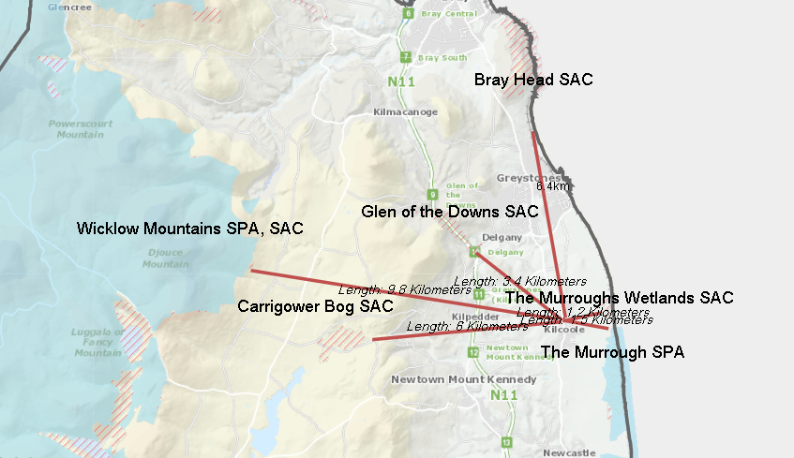

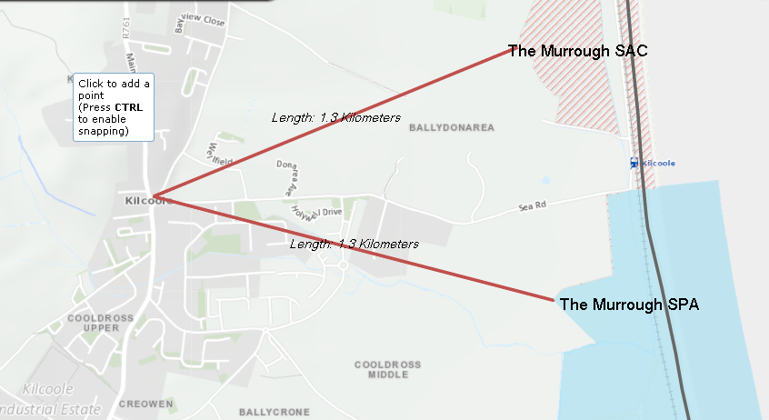
Please answer the following five questions in order to determine whether there are any Natura 2000 sites which could potentially be impacted by the proposed development.

Impacts on SACs

1 | Impacts On Freshwater Habitats  Is the development within a Special Area of Conservation whose qualifying interests include freshwater habitats, or in the catchment of same?  Sites to consider:  Ballyman Glen SAC  Knocksink Wood SAC  Slaney River Valley SAC  Wicklow Mountains SC  Habitats to consider:  Rivers, Lakes and Lagoons. | No
2 | Impacts On Wetland Habitats  Is the development within a Special Area of Conservation whose qualifying interests include wetland habitats, or within 1 km of same?  Sites to consider:  Ballyman Glen  Bray Head  Buckroney- Brittas Dunes & Fen  Carrigower Bog  Holdenstown Bog  Maherabeg Dunes  The Murrough Wetlands  Wicklow Mountains  Habitats to consider:  Bogs, Fens, Marshes and Heaths. | No
3 | Impacts on Intertidal and Marine Habitats  Is the development located within a Special Area of Conservation whose qualifying interests include intertidal and/or marine habitats and species, or within the catchment of same.  Sites to consider:  Bray Head  Buckroney- Brittas Dunes & Fen  Maherabeg Dunes  The Murrough Wetlands  Wicklow Reef  Habitats to consider:  Mudflats, Sandflats, Saltmarsh, Estuary; Shingle, Reefs, Sea Cliffs. | No
4 | Impacts On Woodlands And Grasslands  Is the development within a Special Area of Conservation whose qualifying habitats include woodlands or grasslands habitats, or within 200m of same.  Sites to consider:  Deputy’s Pass Nature Reserve  Glen of the Downs  Knocksink Wood  Vale of Clara (Rathdrum Wood)  Slaney River Valley  Wicklow Mountains  Buckroney- Brittas Dunes & Fen  Maherabeg Dunes  Habitats to consider:  Woodlands, Grasslands or Dunes. | No
Impacts on SPAs

5 | Impacts On Birds  Is the development within a Special Protection Area, or within 1 km of same.  Sites to consider  The Murrough Wetlands  Wicklow Mountains  Poulaphouca Reservoir  Wicklow Head | No

Conclusion Table 2: If the answer to all of these questions is no, significant impacts can be ruled out for Natura 2000 sites. No further assessment is required; proceed to the Habitats Directive Conclusion Statement. Please refer to tables 3 and 4 where the answer to any of these questions is yes.

Table 3: Determination Of Possible Impacts On Natura 2000 Sites.
Where it has been identified that there is a Natura 2000 site within the potential impact zone of the proposed development, it is necessary to try to determine the nature of the possible impacts. Please answer the following questions as appropriate.
1 | Impacts on designated freshwater habitats (rivers, lakes streams and lagoons).  Please answer the following if the answer to question 1 in table 2 was yes.  Does the development involve any of the following:
 | Works inside the boundary of designated site
1.1 | All works within the boundary of any SAC whose qualifying features include freshwater habitats/species, excluding small extensions/alterations to existing buildings. | N/A
 | Works outside the boundary of designated site
1.2 | Discharge to surfacewater or groundwater within the boundary of an SAC whose qualifying features include freshwater habitats/species. | N/A
1.3 | Abstraction from surfacewater or groundwater within 1km of the boundary of an SAC whose qualifying features include freshwater habitats or species. | N/A
1.4 | Removal of topsoil within 100m of the boundary of an SAC, whose qualifying features include freshwater habitats/species. | N/A
1.5 | Infilling or raising of ground levels within 100m the boundary of any SAC whose qualifying features include freshwater habitats/species. | N/A
1.6 | Construction of drainage ditches within 1km of the boundary of an SAC whose qualifying features include freshwater habitats/species. | N/A
1.7 | Installation of waste water treatment systems; percolation areas; septic tanks within 100 m of the boundary of an SAC site whose qualifying features include freshwater habitats/species. | N/A
1.8 | Construction within a floodplain of EU designated watercourse whose qualifying features include freshwater habitats/species. | N/A
1.9 | Crossing or culverting of rivers or streams within 1km of the boundary of any SAC whose qualifying features include freshwater habitats. | N/A
1.10 | Storage of chemicals hydrocarbons or organic wastes within 100 m of the boundary of an SAC whose qualifying features include freshwater habitats/species. | N/A
1.11 | Development of a large scale, within catchment of an EU designated watercourse or waterbody, which involves the production of an EIS. | N/A
1.12 | Development or expansion of quarries within catchment of an EU designated watercourse or waterbody.  . | N/A
1.13 | Development or expansion of windfarms within catchment of an EU designated watercourse or waterbody. | N/A
1.14 | Development of pumped hydro electric stations within catchment of an EU designated watercourse or waterbody. | N/A
2 | Impacts on designated wetland habitats (bog, heath, marsh, fen).  Please answer the following if the answer to question 2 in table 2 was yes.  Does the development involve any of the following:
 | Works inside the boundary of designated site
2.1 | All works within the boundary of an SAC whose qualifying features include heath, marsh, fen or bog, excluding small extensions/alterations to existing buildings. | N/A
 | Works outside the boundary of designated site | N/A
2.2 | Construction of roads or other infrastructure on peat habitats within 1km of any SAC whose qualifying features include heath, marsh, fen or bog. | N/A
2.3 | Development of a large scale within 1km of any SAC, whose qualifying features include heath, marsh, fen or bog, which involves the production of an EIS. | N/A
3 | Impacts on designated intertidal and marine habitats (mudflats, sandflats, estuaries, reefs and sea cliffs).  Please answer the following if the answer to question 3 in table 2 was yes.  Does the development involve any of the following:
 | Works inside the boundary of designated site
3.1 | All works within the boundary of any SAC whose qualifying features include intertidal or marine habitats, excluding small extensions/alterations to existing buildings. | N/A
 | Works outside the boundary of designated site | N/A
3.2 | Coastal protection works within 5km of any SAC whose qualifying features include intertidal or marine habitats. | N/A
3.3 | Development of piers, slipways, marinas, pontoons or any other infrastructure within 5km of any SAC whose qualifying features include intertidal or marine habitats. | N/A
3.4 | Dredging within 5km of any SAC whose qualifying features include intertidal or marine habitats. | N/A
3.5 | Works within 1km of any SAC whose qualifying features include intertidal or marine habitats, which will result in discharges to rivers or streams directly connected to the designated site. | N/A
3.6 | Infilling of coastal habitats within 500m of any SAC whose qualifying features include intertidal or marine habitats. | N/A
3.7 | Removal of topsoil or infilling of terrestrial habitats within 100m of any SAC whose qualifying features include intertidal or marine habitats. | N/A
3.8 | Development of a large scale within 1km of any SAC whose qualifying features include intertidal or marine habitats, which involves the production of an EIS. | N/A
4 | Impacts on other designated woodlands and grasslands (woodland, upland grassland, lowland grassland, coastal grassland including dunes).  Please answer the following if the answer to question 4 in table 2 was yes.  Does the development involve any of the following:
 | Works inside the boundary of designated site
4.1 | All works within the boundary of any SAC whose qualifying interests include woodland or grassland habitat types excluding small extensions/alterations to existing buildings. | N/A
 | Works outside the boundary of designated site
4.2 | Development within 200m of any SAC whose qualifying interests include woodland or grassland habitat types. | N/A
4.3 | Development of a large scale within 1km of any SAC, whose qualifying interests include woodland or grassland habitat types, which involves the production of an EIS. | N/A
5 | Impacts on birds in SPAs  Please answer the following if the answer to question 5 in table 2 was yes.  Does the development involve any of the following:
 | Works inside the boundary of designated site
5.1 | All works within the boundary of any SPA excluding small extensions/alterations to existing buildings. | N/A
 | Works outside the boundary of designated site | N/A
5.2 | Erection of wind turbines within 1km of any SPA. | N/A
5.3 | All construction works within 100m of any SPA. | N/A
5.4 | Infilling of coastal habitats within 500m of intertidal SPA. | N/A
5.5 | Works within 1km of coastal/wetland SPAs which will result in discharges to rivers or streams that are directly connected to designated sites. | N/A
5.6 | Development of cycleways or walking routes within 100m of SPAs. | N/A

Conclusion Table 3: If the answer to all of the above is no or n/a, significant impacts on Natura 2000 sites can be ruled out. No further assessment is required; proceed to the Screening Conclusion Statement. If the answer to any question in table 3 is yes, you may require further information, unless you are satisfied that the project proponents have incorporated adequate mitigation into their design to avoid impacts on the Natura 2000 site (eg water pollution protection measures). Such information should be provided in the form of a Natura Impact Statement which should address the particular issues of concern as identified through the above.

Table 4: Consideration Of Potential Impacts On Protected Species
Many of our Special Areas of Conservation are designated for species as well as for habitats. These are listed below, alongside the sites for which they are designated. Included is a short list of the types of activities which could have an impact on these species. Please tick if you are concerned that the proposed development could have an impact on these species.

Species | Relevant Sites | Activites which could have impacts on species | Possible Impacts Identified? Y/N
Otter | Wicklow Mountains  Slaney River Valley | Activities that interfere with river banks. | N
Salmon | Slaney River Valley | Activities that interfere with water quality, levels or the river bed; | N
River Lamprey | Slaney River Valley | Activities that interfere with water quality, levels or the river bed; | N
Brook Lamprey | Slaney River Valley | Activities that interfere with water quality, levels or the river bed; | N
Sea Lamprey | Slaney River Valley | Activities that interfere with water quality or the river bed – estuarine areas; | N
Twaite Shad | Slaney River Valley | Activities that interfere with water quality or the river bed – estuarine areas; | N
Freshwater Pearl Mussel | Slaney River Valley | Activities that interfere with water quality, levels or the river bed ; | N

Conclusion Table 4: If the answer to all of the above is no, significant impacts on species can be ruled out. If the answer to any of the above is yes, then further information is likely to be required in relation to potential for impact on that particular species. Where potential impacts on the above listed species are within designated sites, then further information should be sought in the form of a Natura Impact Statement. Where impacts are outside designated sites, then a species specific survey should be requested.

Habitats Directive Screening Conclusion Statement

Development Type |  | 4 No 1 bed apartments
Development Location |  | Former HSE site, Main Street, Kilcoole,  Co. Wicklow
Natura 2000 sites within impact zone |  | 0
Planning File Ref |  | Part 8
Description of the project

4 No 1 bed apartments at 12 Mill Road, Killincarrig, Greystones, Co. Wicklow.

Describe how the project or plan (alone or in combination) could affect Natura 2000 site(s).

N/A

If there are potential negative impacts, explain whether you consider if these are likely to be significant, and if not, why not.
N/A

Conclusion of assessment

Significant impacts can be ruled out.

Documentation reviewed for making of this statement.

Wicklow CDP 2016-2022
Geological Survey of Ireland Site Topography Investigation

Completed By | Gillian Power, Senior Executive Engineer,  Housing and Corporate Estate,  Wicklow Co. Co., Wicklow.
Date | 09 June 2021

